**University of Pittsburgh IEEE Corporate sponsorship package**

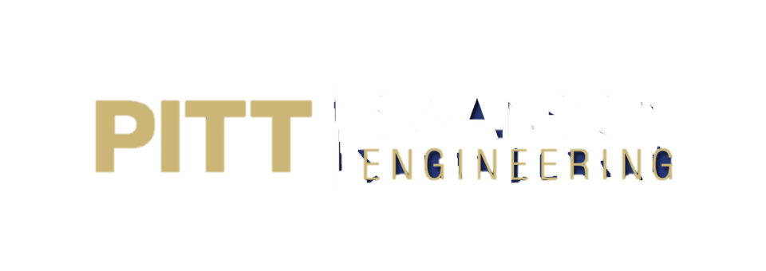

**IEEE Sponsor Information**

With 220 technical student members, the Pitt IEEE is growing annually. However, our ambitions require financial support to be better equipped to provide our members with events and projects.  By supporting the IEEE, you are not only aiding young engineers, but also advertising your company to the most driven ECE and CS students that Pitt has to offer.  You will gain access to one of the world’s richest pools of young engineering professionals.

During the school year, we work actively to cultivate our members’ interpersonal skills through professional development meetings, company information sessions, and social events. Each spring, students also have the opportunity to collaborate with local IEEE chapters at the annual Region II Student Activities Conference. We encourage students from a variety of backgrounds to pursue specific interests within electrical and computer engineering.

Thank you for taking time out of your day to see how you can make a difference to our organization. Your support allows for the Pitt IEEE to provide the resources our engineers need so we can foster excellence, innovation, and growth at the University of Pittsburgh.

Please feel free to contact us at [ssoeieee@gmail.com](mailto:ssoeieee@gmail.com) with any questions or concerns.

# **https://lh4.googleusercontent.com/CUXO3Djtx_cVz84y5uwdCU0TmdFcG-WY-_P0NFcsizdh3ZWrQGqE_I__li0zmgMOXBV_3S9DVBMb4lxwFLYLTNDOlp4qSCP7IDHNS4NdAXdjZMJyO5bVQ-z-QeLJvKbT1jX2quteProfessional Development**

## **Company Information Session**

IEEE info sessions provide students with a more focused and in-depth view of a company than the small snippet provided by the multitude of companies present at the Career Fair. Info sessions are one of our most popular events and allow our students to interact with employers in a more low-key and informal environment.

**Industry Lunch ’n Learn**

Students will receive guidance from industry members at catered lunch. The Industry Lunch ‘n Learn allows students to develop a more personal relationship with companies in a relaxed setting.

**On-Site Company Visits**

Throughout the year, the Pitt IEEE sponsors educational trips for its members. We hope to incorporate trips to industry and company sites, so that students will gain an insider's view to how companies function, along with learning about job opportunities.

**ECE Resume Building Workshop**

This event is geared toward helping undergraduate students build a proper resume that shows off their skills while making it attractive to companies.

**Technical Events and Projects**

# **https://lh6.googleusercontent.com/IB5OuhiMxqppJnmszah7bT_HvUWu1pL5JXTEZbiP00iyzXN6kzLpiX9NfXCN53y_CefFCXxh_jEQ0zzNr5WcTS5LFd6tPxJKYWQThvQy4d8QhWQ_4PAf7MHDv9nQjiH2W_Opm5JUSkill-Building Workshops**

# At our most recent workshop, Arduinnovation, students with skill levels ranging from beginner to advanced collaborated on their current projects, started new projects, and learned new applications of the Arduino microprocesser. This semester, we are also hosting an Android app development event.

**SteelHacks**

IEEE supports SteelHacks, Pittsburgh’s premier annual hackathon. With over 300 makers from across the globe and the unified goal of celebrating innovation and creation, SteelHacks is the biggest event of its kind at Pitt.

**Faculty Research Presentations**

These lectures help students stay updated on current research within the ECE department and discover research opportunities. Sponsorship includes funding for food. The sponsor’s logo will be displayed at the event and all advertising.

## **INTERPERSONAL DEVELOPMENT**

## **IEEE SAC 2015 Representatives.JPGIEEE Region 2 Student Activities Conference**

Each year, Pitt IEEE sends students to represent the University at the IEEE Region 2 Student Activities Conference.  At this event, students have the opportunity to participate in a career fair, attend lectures given by leaders from industry, and compete in electrical engineering-related competitions.

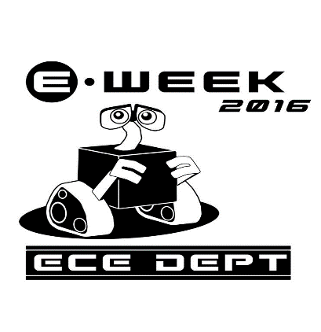

**E-Week**

Pitt’s engineering department annually celebrates Engineers week by planning events that allow all of the different disciplines to compete in fun games and activities. IEEE is the most active group coming from the ECE department. Many of our members take part in the events. We are very proud to say that, with the help of our members, we won in 2015!

**Sponsorship Tiers**

***Platinum: $2000***

* Company logo and profile on website
* 2 company information sessions per year with food provided
* 2 sponsored events
* Send representative to 2 general body meetings
* Company recognition at general body meetings
* Access to IEEE Resume Book

***Gold: $1000***

* Company logo and profile on website
* 2 company information sessions per year with food provided
* Send representative to 1 general body meeting
* Company recognition at general body meetings
* Access to IEEE Resume Book

***Silver: $500***

* Logo on website
* 1 company information session per year with food provided
* Company recognition at general body meetings

***Bronze: $200***

* Logo on website
* Company recognition at general body meetings